**LAB – 12**

18MIS7250

Amit Kumar Sahu

**HDLC, PPP, PAP & CHAP**

High-level Data Link Control (**HDLC**) is a group of communication protocols of the data link layer for transmitting data between network points or nodes. Since it is a data link protocol, data is organized into frames. A frame is transmitted via the network to the destination that verifies its successful arrival.

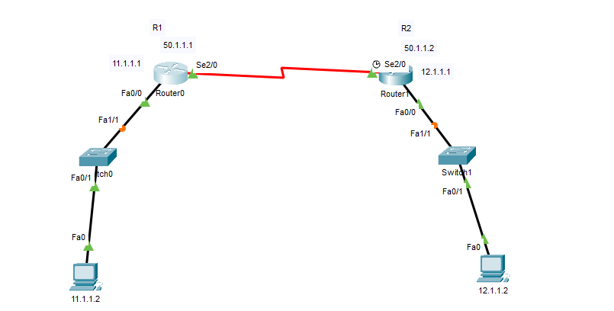

In computer networking, Point-to-Point Protocol (**PPP**) is a Data link layer (layer 2) communications protocol between two routers directly without any host or any other networking in between. It can provide connection authentication, transmission encryption, and compression

**Configuring router 0**

Router>en

Router#conf t

Enter configuration commands, one per line. End with CNTL/Z.

Router(config)#int f0/0

Router(config-if)#exit

Router(config)#interface FastEthernet0/0

Router(config-if)#no shutdown

Router(config-if)#

%LINK-5-CHANGED: Interface FastEthernet0/0, changed state to up

%LINEPROTO-5-UPDOWN: Line protocol on Interface FastEthernet0/0, changed state to up

Router(config-if)#ip add 11.1.1.1 255.0.0.0

Router(config-if)#no shut

Router(config-if)#no shutdown

Router(config-if)#int s2/0

Router(config-if)#ip add 50.1.1.1 255.0.0.0

Router(config-if)#no shut

%LINK-5-CHANGED: Interface Serial2/0, changed state to down

Router(config-if)#clock rate 64000

This command applies only to DCE interfaces

Router(config-if)#clock rate 64000

This command applies only to DCE interfaces

Router(config-if)#exit

Router(config)#ip route 0.0.0.0 0.0.0.0 50.1.1.2

Router(config)#

**Configuring router 1**

Router(config)#interface FastEthernet0/0

Router(config-if)#ip add 12.1.1.1 255.0.0.0

Router(config-if)#no shut

Router(config-if)#

Router(config)#int

% Incomplete command.

Router(config)#interface FastEthernet1/0

Router(config-if)#

Router(config-if)#exit

Router(config)#interface FastEthernet0/0

Router(config-if)#no shutdown

Router(config-if)#

%LINK-5-CHANGED: Interface FastEthernet0/0, changed state to up

%LINEPROTO-5-UPDOWN: Line protocol on Interface FastEthernet0/0, changed state to up

Router(config-if)#int s2/0

Router(config-if)#ip add 50.1.1.2 255.0.0.0

Router(config-if)#no shut

**ROUTER 0 Configuration there is default hdlc**

Router#sh int serial 2/0

Serial2/0 is up, line protocol is up (connected)

Hardware is HD64570

Internet address is 50.1.1.1/8

MTU 1500 bytes, BW 128 Kbit, DLY 20000 usec,

reliability 255/255, txload 1/255, rxload 1/255

Encapsulation HDLC, loopback not set, keepalive set (10 sec)

Last input never, output never, output hang never

Last clearing of "show interface" counters never

Input queue: 0/75/0 (size/max/drops); Total output drops: 0

Queueing strategy: weighted fair

Output queue: 0/1000/64/0 (size/max total/threshold/drops)

Conversations 0/0/256 (active/max active/max total)

Reserved Conversations 0/0 (allocated/max allocated)

Available Bandwidth 96 kilobits/sec

5 minute input rate 0 bits/sec, 0 packets/sec

5 minute output rate 0 bits/sec, 0 packets/sec

0 packets input, 0 bytes, 0 no buffer

Received 0 broadcasts, 0 runts, 0 giants, 0 throttles

0 input errors, 0 CRC, 0 frame, 0 overrun, 0 ignored, 0 abort

0 packets output, 0 bytes, 0 underruns

0 output errors, 0 collisions, 1 interface resets

0 output buffer failures, 0 output buffers swapped out

ROUTER 1 aldso config default hdlc

Router#sh int serial 2/0

Serial2/0 is up, line protocol is up (connected)

Hardware is HD64570

Internet address is 50.1.1.2/8

MTU 1500 bytes, BW 128 Kbit, DLY 20000 usec,

reliability 255/255, txload 1/255, rxload 1/255

Encapsulation HDLC, loopback not set, keepalive set (10 sec)

Last input never, output never, output hang never

Last clearing of "show interface" counters never

Input queue: 0/75/0 (size/max/drops); Total output drops: 0

Queueing strategy: weighted fair

Output queue: 0/1000/64/0 (size/max total/threshold/drops)

Conversations 0/0/256 (active/max active/max total)

Reserved Conversations 0/0 (allocated/max allocated)

Available Bandwidth 96 kilobits/sec

5 minute input rate 0 bits/sec, 0 packets/sec

5 minute output rate 0 bits/sec, 0 packets/sec

0 packets input, 0 bytes, 0 no buffer

Received 0 broadcasts, 0 runts, 0 giants, 0 throttles

0 input errors, 0 CRC, 0 frame, 0 overrun, 0 ignored, 0 abort

0 packets output, 0 bytes, 0 underruns

0 output errors, 0 collisions, 1 interface resets

0 output buffer failures, 0 output buffers swapped out

**Enabling PPP on both the routers**

Router(config)#int s2/0

Router(config-if)#encapsulation PPP

Router(config-if)#

%LINEPROTO-5-UPDOWN: Line protocol on Interface Serial2/0, changed state to down

Checking if it’s working fine

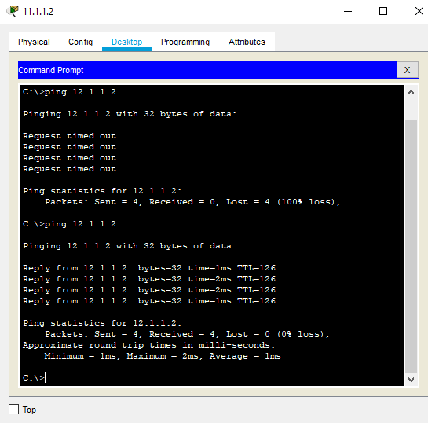

**Challenge-Handshake Authentication Protocol**

In computing, the Challenge-Handshake Authentication Protocol authenticates a user or network host to an authenticating entity.

**What if a person configures a same router as we have and tries to steal the encapsulated data.? So for this we will use PAP - Password Authentication Protocol**

Router>en

Router#conf t

Enter configuration commands, one per line. End with CNTL/Z.

Router(config)#hostname R1

R1(config)#enable password cosco

R1(config)#username R2 password cosco

R1(config)#int s2/0

R1(config-if)#encapsulation PPP

R1(config-if)#ppp authentication ?

chap Challenge Handshake Authentication Protocol <CHAP>

pap Password Authentication Protocol <PAP>

R1(config-if)#

%LINEPROTO-5-UPDOWN: Line protocol on Interface Serial2/0, changed state to down

R1(config-if)#ppp pap sent-username R1 password cosco

R1(config-if)#

%LINEPROTO-5-UPDOWN: Line protocol on Interface Serial2/0, changed state to up

Router 2nd configuration

Router#conf t

Enter configuration commands, one per line. End with CNTL/Z.

Router(config)#

Router(config)#hostname R2

R2(config)#enable password cosco

R2(config)#

%LINEPROTO-5-UPDOWN: Line protocol on Interface Serial2/0, changed state to down

R2(config)#int s2/0

R2(config-if)#encapsulation ppp

R2(config-if)#ppp authentication pap

R2(config-if)#^Z

R2#

%SYS-5-CONFIG_I: Configured from console by console

R2#conf t

Enter configuration commands, one per line. End with CNTL/Z.

R2(config)#username R1 password cosco

R2(config)#

R2(config)#int s2/0

R2(config-if)#ppp pap sent-username R2 password cisco

R2(config-if)#

**Restarting Both The Routers And Configuring CHAP**

R1(config-if)#int s2/0

R1(config-if)#encapsulation ppp

R1(config-if)#ppp authentication chap

R1(config-if)#

R1(config-if)#exit

R1(config)#username R2 password cisco

